Use-Case Realization Report (Design)
Add Survey

Issue <1.0>
Revision History
Date | Issue | Description | Author
<15/Oct/09> | <1.0> | <Initial version> | <Thomas Yap>

Table of Contents
1. Brief Description 4
2. Flow of Events 4
2.1 Standard Flow 4
2.1.1 Add Survey 4
3. Interaction Diagrams 5
3.1 Collaboration Diagram for Add Survey 5
3.2 Sequence Diagram for Add Survey 6
4. Participating Objects 8
5. Class Diagrams 8
5.1 Class Diagram for Add Survey 8
6. Derived Requirements 8

Use-Case Realization Report
Add Survey

Brief Description
This use case enables the controller to add new survey to Survey Pool. It involves displaying the menu and form for keying in the survey details.

Flow of Events
The standard flow of events for this use case and any exceptions are described in the following subsections. The events are described in terms of Actors and Design Objects.

Standard Flow
This use case covers the Survey Maintenance - Add Survey. The standard flows of these events are described below.

Add Survey
The running of the application is shown in section 3.1. The flow of event is as follow:

- When the application start, the first operation to be performed is the startup operation of the main controller. This operation will create all the control objects and the entity objects necessary for operation Add Survey:
  - The control object created is: SurveyBL Controller
  - The entity objects create are: survey_master, survey_qn_master, survey_question_option

- The main controller will start the main function menu:
  - To start Add Survey, operation page_load() is activated by SurveyBL Controller to display a Survey form.
  - Portal Admin then input the data.
  - Operation validation will validate the format of the entries.
  - Then SurveyBL Controller will check for duplication.
  - If no issue found, Survey Controller will send a confirmation request to form Survey Interface.
  - Upon confirmation, the data will then be written to table using operation insertsurvey() to entity object Survey.
  - After that, portal admin can opt to create questions for the survey by clicking Manage Question button.
  - Page_load() is activated to display Question screen.
  - Portal then click the Add button to activate Question Maintenance screen.
  - ()The portal admin fills in the question and options details. InsertQuestion() and InsertQuestionOption) will be executed for creating new record.
  - The adding request can be cancelled by clicking cancel button and no data will be stored.
  - A confirmation message will be displayed by form Survey interface.

- Step 2 will be repeated until all new entries are added to the system. Then controller will terminate the application by issuing operation close.

Interaction Diagrams

Collaboration Diagram for Add Survey
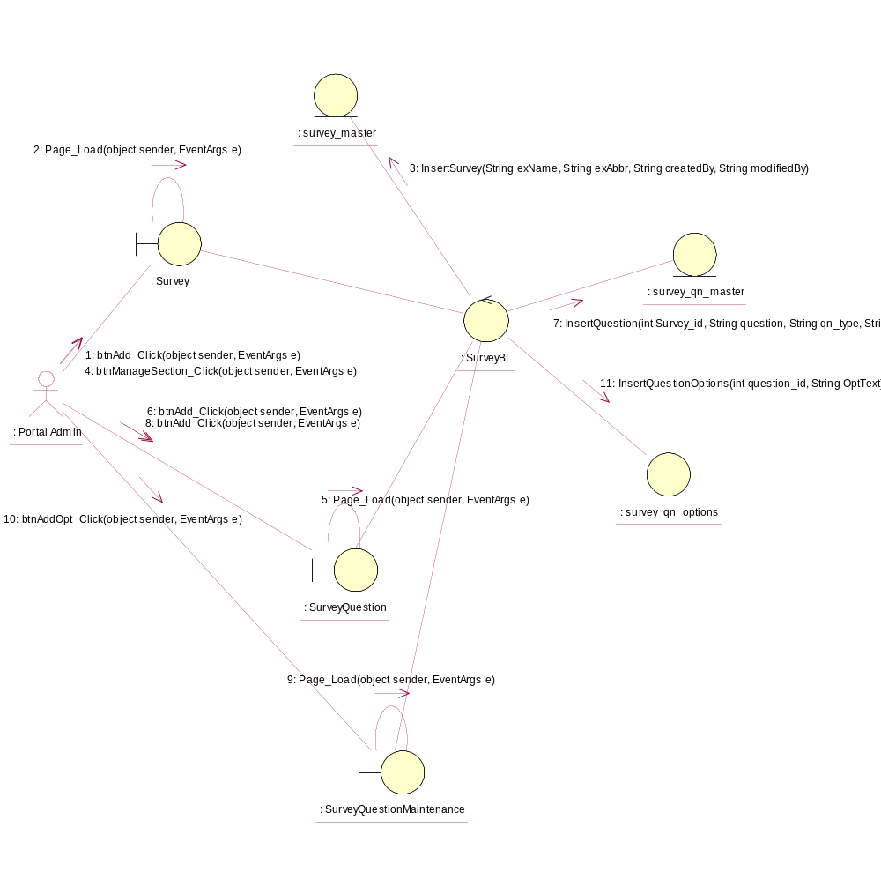

Sequence Diagram for Add Survey
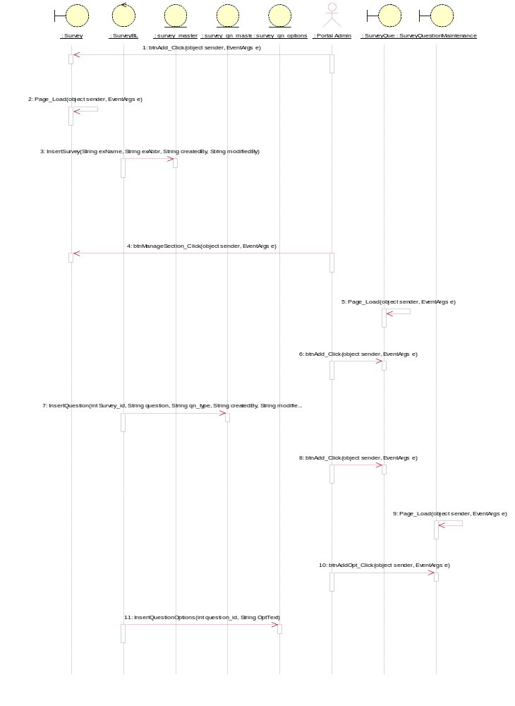

Participating Objects
: Portal Admin

: Survey

: survey_master

: survey_qn_master

: survey_qn_options

: SurveyBL

: SurveyQuestion

: SurveyQuestionMaintenance

Class Diagrams

Class Diagram for Add Survey
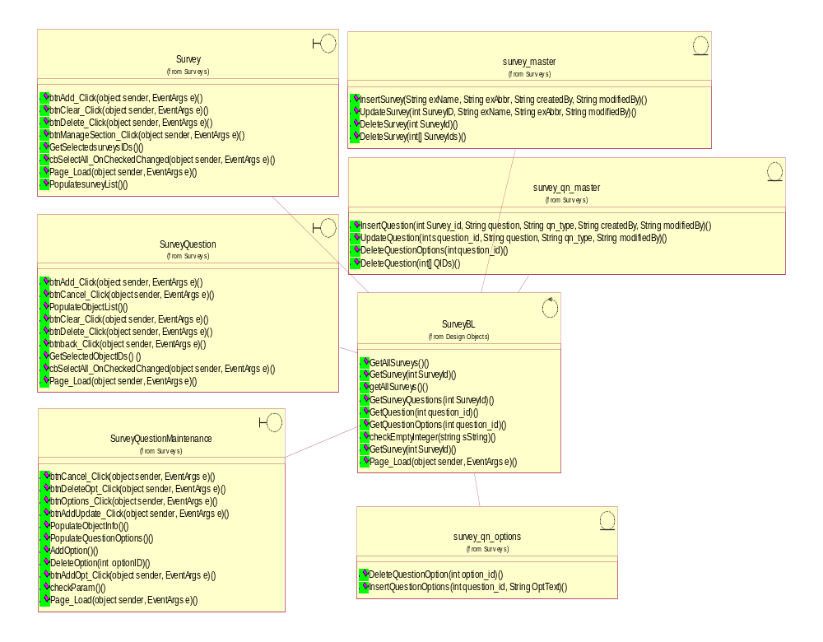

Derived Requirements
[enter the derived requirements here]

